Best Practices

Ad Changes Triggering Ad Reviews
If you make any changes to the following scenarios, your ad will be triggered for review:
- Any changes to your creative (image, text, link, video, and so on)
- Any changes to targeting
- Any changes of optimization goals and billing events may also trigger review
Note: Changes to bid amount, budget, and ad set schedule will not have any effect on the review status.
Additionally, if an ad enters Ad Review with the run status of "Paused", then it will remain Paused upon exiting Ad Review. Otherwise, the ad will be considered Active and ready to deliver.

Pagination
For paging response data, see the Graph API Pagination.

User Information
You should store user IDs, session keys, and the ads account ID so it is easy to programmatically access them and keep them together. This is important because any calls made with an account ID belonging to one user and the session key for another user will fail with a permissions error. Any storages of user data must be done in compliance with Facebook Platform Terms and Developer Policies.

Suggested Bids
Run frequent reports on your campaigns, as suggested bids change dynamically in response to bidding by competitors using similar targeting. Bid suggestions get updated within a few hours, depending upon the bidding of competitors.

Batch Requests
Make multiple requests to the API with a single call, see:
- Multiple Requests
- Batch Requests
You can also query for multiple objects by ID as follows:
https://graph.facebook.com/<API_VERSION>?ids=[id1,id2]
To query for a specific field:
https://graph.facebook.com/<API_VERSION>?ids=[id1,id2]&amp;fields=field1,field2

Check Data Changes using ETags
Quickly check if the response to a request has changed since you last made it, see:
- ETags blog
- ETags Reference

Object Archive and Delete Status
Ad objects have two types of delete states: archived and deleted. You can query both archived and deleted objects with the object id. However, we do not return deleted objects if you request it from another object's edge.
You can have up to 5000 archived objects at any time. You should move ad objects from archived states to deleted states if you no longer need to retrieve them via edges. To learn how states work and for sample calls see Storing Ad Objects.

Viewing Errors
People make mistakes and try to create ads that are not accepted, Error Codes provide reasons an API call failed. You should share some form of the error to users so they can fix their ads.

Facebook Marketing Developer Community Group
Join Facebook Marketing Developer Community group on Facebook for news and update on for Marketing API. We post items from the Marketing API blog to the group.

Testing
Sandbox mode is a testing environment to read and write Marketing API calls without delivering actual ads. See Sandbox Mode for Developers
Try API calls with Graph API Explorer. You can try any API call you would like to make to the Marketing API, see blog post. Select your app in App, and grant your app ads_management or ads_read permission in extended permissions when you create an access token. Use ads_read if you only need Ads Insights API access for reporting. Use ads_management to read and update ads in an account.
For development and basic access, configure a list of ad accounts your app is able to make API calls for, see account list.
You can use sandbox mode to demonstrate your app for app review. However in sandbox mode you cannot create ads or ad creative. Therefore you should use hard coded ad IDs and ad creative IDs to demonstrate your use of our API for app review.

Basic Criteria
- Demonstrate value beyond Facebook's core solutions, such as Facebook Ads Manager.
- Focus on business objectives, such as increase in sales. Facebook business objectives can be found here.

Policies
Understand the API policies; Facebook has the right to audit your activity anytime:
- Platform Terms
- Developer Policies
- Promotion Policies
- Data Use Policy
- Statement of Rights and Responsibilities
- Advertising Guidelines
Be ready to adapt quickly to changes. Most changes are versioned and change windows are 90 days, ongoing.
In Statement of Rights and Responsibilities, you are financially and operationally responsible for your application, its contents, and your use of the Meta Platform and the Ads API. You should manage your app's stability and potential bugs.

Opportunity Score and Recommendations
Opportunity score and recommendations enable advertisers to discover and implement best practices that can optimize their ad campaigns with Meta. This guide will help you understand the components of opportunity score and how to integrate them with your application.
Opportunity score is a tool for understanding how well-optimized an ad account is for achieving optimal performance and generates recommendations that could improve performance. It consists of two parts:
- Your opportunity score (range: 0–100) — Reflects how optimized your ad account is. A higher score indicates better optimality and a greater likelihood of improved performance over time.
  - Opportunity score is provided as a field of an ad account.
  - Opportunity score is updated in near real-time in response to campaign changes and the application of available recommendations.
- Recommendations — Experimentally-proven best practices that are personalized to each ad account. They may relate to your campaigns, ad sets, or ads, and have been rigorously tested to show they can deliver statistically significant performance improvements.*
  - Implementing recommendations will improve setup and increase opportunity score.
  - Recommendations have assigned point values based on how much each is expected to improve your campaign performance.*
  - You may see recommendations related to a variety of categories including campaign objectives and goals, audience, automation, creative and placements, budget and bidding, or signals.
* Note: Meta is frequently testing new types of recommendations on the Ads Manager Web UI. Under certain circumstances, there could be fewer recommendations returned by the API versus what is shown in Ads Manager.
By applying performance recommendations from Meta, you agree to the Facebook Terms of Service including your obligation to comply with the Self-serve ad terms, the Commercial terms, and the Facebook Advertising Policies.

Supported Inventory and APIs

Fetching recommendations
To fetch all the recommendations available for your ad account, make a GET request to the /act_<AD_ACCOUNT_ID>/recommendations endpoint where <AD_ACCOUNT_ID> is the ID for your Meta ad account.

Example request
curl -G \
-d 'access_token=<ACCESS_TOKEN>' \
https://graph.facebook.com/v24.0/act_<AD_ACCOUNT_ID>/recommendations

Example response
On success, your app receives a list of recommendations that Meta has generated. If this list is empty, Meta has not identified any changes that can be made to increase the ads performance in your ad account.
{
"data": [
{
"recommendations": [
{
"recommendation_signature": "1234567",
"type": "AUTOFLOW_OPT_IN",
"object_ids": ["7656787679008", "2345678765423", ...],
"recommendation_content": {
"lift_estimate": "Up to 3% more Traffic",
"body": "2 of your ad sets have similar objectives and creatives..",
"opportunity_score_lift": "14"
},
"url": "https://adsmanager.facebook.com/adsmanager/...."
}
],
}
]
...
}

Parameters
Name | Description
recommendation_signature | Unique identifier for this recommendation. Required to refer to this recommendation in the recommendation application API.  For recommendations that cannot be resolved in the API, this value will not be returned.
type | Enum value denoting what type of recommendation this is. Description of what each possible value means and what applying them entails is provided in the Applying recommendations secion below.
object_ids | List of ads objects that pertain to this recommendation. May be a campaign, ad set, or ad.
lift_estimate | Describes the improvement that could see in accepting a given recommendation.
body | This is a description of the recommendation similar to the descriptions listed in teh Performance recommendation types section below.
opportunity_score_lift | This is the lift in opportunity score that would be expected from applying this recommendation.
url | This is the URL that links directly to the user flow in Ads Manager to apply the recommendation.

Applying recommendations
To apply a recommendation for your ad account, make a POST request to the /act_<AD_ACCOUNT_ID>/recommendations endpoint where <AD_ACCOUNT_ID> is the ID for your Meta ad account.

Parameters
The recommendation application API supports the following parameters.
Name | Description
recommendation_signature  string | Required.  Signature provided in the recommendation fetching API, which corresponds to a unique recommendation.
music_parameters  object | Optional.  Music recommendation parameters. Specific parameters are listed below.
autoflow_parameters  object | Optional.  Autoflow opt-in recommendation parameters. Specific parameters are listed below.
fragmentation_parameters  object | Optional.  Fragmentation recommendation parameters. Specific parameters are listed below.

The music_parameters object
Name | Description
object_selection  array of numeric strings | Optional.  A list of ad IDs to apply the music recommendation to. List must be a subset of provided IDs in object_ids.

The autoflow_parameters object
Name | Description
object_selection  array of numeric strings | Optional.  A list of ad IDs to apply the autoflow opt-in recommendation to. List must be a subset of provided IDs in object_ids.

The fragmentation_parameters object
Name | Description
object_selection  array of numeric strings | Optional.  A list of ad set IDs to apply the fragmentation recommendation to. List must be a subset of provided IDs in object_ids.

Example request
curl -X POST \
-d 'access_token=<ACCESS_TOKEN>' \
-d 'recommendation_signature="1234567"' \
-d 'music_parameters={"object_selection": ["7656787679008"]}' \
https://graph.facebook.com/v24.0/act_<AD_ACCOUNT_ID>/recommendations

Example response
On success, your app receives a Boolean value denoting whether the recommendation was successfully applied. If it was not successfully applied, your ad objects will remain unchanged.
{
"success": true
}

Performance recommendation types
These are the currently supported performance recommendation types and what happens when the recommendation is succcessfully applied.
Name | Description
MUSIC | Allow Meta to automatically select and add music to your ads, at no cost to you, based on their content.  Applying this recommendation will enable this functionality for the selected ads objects. If no selection is provided, it will be enabled for all listed ads objects.  Use of music in your ads is subject to the Sound Collection Terms.
AUTOFLOW_OPT_IN | Enable standard enhancements, which leverages Meta's data to deliver different variations of your ad when likely to improve performance.  Applying this recommendation will enable this functionality for the selected ads objects. If no selection is provided, it will be enabled for all listed ads objects.
AUTOMATIC_PLACEMENTS | Allow Meta to automatically select additional placements for your ad sets while making the most of your budget. Learn more about Advantage+ Placements.
UNCROP_IMAGE | Expand your images to fit more placements. You can use generated images that expand the aspect ratios of your media, which can fit your ad into new placements and show them to more people.  Applying this recommendation will enable this functionality for the selected ads objects. If no selection is provided, it will be enabled for all listed ads objects.
FRAGMENTATION | Some of your ad sets have similar setups and creatives, but different audiences. As a result, they may take longer to exit the learning phase and spend more budget before performance has optimized. To optimize your ads spending, combine your similar ad sets into one ad set.  Applying this recommendation will perform the following changes:  - The top performing ad set will remain on, while the rest are turned off. The top performing ad set will be the one listed in object_ids.  - Targeting selections from the ad sets which are turned off will be merged into top performing ad set. For example, if Ad Set 1 targeted 18-25 year olds and Ad Set 2 targeted 35-40 year olds, your combined ad set would target 18-40 year olds. Your audience changes will include: Locations included.  - Ads from the ad sets which are turned off will be included in the top performing ad set.  - Budgets from the ad sets which are turned off will be added to the budget of the top performing ad set.
CREATIVE_FATIGUE | Cost per result for this ad set may be higher than ads you ran in the past because its image or ide has been show to parts of your audience too many times.  Applying this recommendation requires an ad ID and creative ID, and will create a copy of the provided ad, except with the provided new creative.
CREATIVE_LIMITED | Cost per result for this ad set may be higher than ads you ran in the past because its image or ide has been show to parts of your audience too many times.  Applying this recommendation requires an ad ID and creative ID, and will create a copy of the provided ad, except with the provided new creative.
SIGNALS_GROWTH_CAPI | By integrating the Conversions API, you can get more accurate data about the conversions from your Meta ads, which will improve audience targeting and help lower your cost per result.  Get started with the Conversions API.  Note: This recommendation currently cannot be applied through Marketing API.
CAPI_PERFORMANCE_MATCH_KEY | Your ads performance can benefit from sending additional fields within your existing conversions reporting.  Please review your Meta Pixel integration in Events Manager.  Note: This recommendation currently cannot be applied through Marketing API.
SCALE_GOOD_CAMPAIGN | Some ad sets or campaigns have had stable delivery and a lower cost per result compared to ad sets and campaigns with the same optimization goal that you or your peers have run. Increase their budgets to further scale your results.
SHOPS_ADS | Multiple ad sets in your account use the website conversion location. Help improve your ad performance by selecting website and shop for their conversion location. This lets you automatically send traffic either to your website or shop on Facebook or Instagram.
ADVANTAGE_PLUS_AUDIENCE | Leverage Advantage+ audiences to let Meta automatically identify and target the most relevant audience segments for your ad sets, optimizing your budget for maximum impact. Learn more about Advantage+ Audiences.
AD_LIFT_RECALL_OPTIMIZATION_GOAL | Create a new awareness campaign with the performance goal "Maximize ad recall lift" to help more people remember your brand.
ADVANTAGE_PLUS_CATALOG_ADS | Create a campaign using Advantage+ catalog to deliver personalized ads to new and existing interested shoppers based on their behaviors, interests, and intent.
BACKGROUND_GENERATION | Help your products stand out by using AI-generated backgrounds with eligible product images to show the version thats likely to perform best.
BUDGET_LIMITED | Your current budget may be limiting the performance of your campaigns. You could get more results by increasing the budget.
CAPI_CRM_GUIDANCE | Connect your CRM with the Conversions API to help optimize the quality of your leads, which can lead to more conversions.
CONVERSION_LEADS_OPTIMIZATION | Choose "Maximize number of conversion leads" as your performance goal to help lower the cost of reaching people most likely to convert.
CTX_CREATION_PACKAGE | Use a "Tailored messages" campaign to simplify campaign creation and help get more messages at the best value.
CTX_HVS | Duplicate your campaign as an "Engagement" campaign with "Maximize number of conversations" as the performance goal to help drive more conversations at a lower cost.
DELIVERY_ERROR | None of the ad sets within this campaign are running. Each ad set has at least one error that needs to be resolved.
DYNAMIC_ADVANTAGE_CAMPAIGN_BUDGET | Spend less of your budget on underperforming ad sets and more on ad sets with the best opportunities. You can set limits or scheduling for each ad set.
LANDING_PAGE_VIEW_OPTIMIZATION_GOAL | Create a campaign with the performance goal of "Maximize landing page views" to deliver ads to audiences who are most likely to visit your website.
LEAD_ADS_GUIDANCE | Lower your cost per lead and create your campaign in fewer steps using a tailored leads campaign, a preset with built-in best practices to help you get more leads at the best value.
MESSAGING_EVENTS | Set up your purchase events through WhatsApp or a messaging partner, and then select the "Maximize purchases" optimization through the "Messaging performance" goal to help lower costs.
MESSAGING_PARTNERS | Work with a messaging partner to help manage incoming messages, generate leads, and provide extensive analytics to optimize your conversations and conversions.
MIXED_FORMATS | Use a mix of videos and images in your campaign to reach users in different ways.
MULTI_TEXT | Select more text options so they can be mixed and matched to create different versions of your ad. The version that may perform best will be shown for each placement.
OFFSITE_CONVERSION | Select the "Maximize number of conversions" performance goal to help drive new customers to your website and lower your cost per result.
PERFORMANT_CREATIVE_REELS_OPT_IN | Select "Reels" placements for ads already using media that works well in Reels placements, so people are more likely to interact with them.
PIXEL_OPTIMIZATION_HIE | Set up "Purchase events" with Meta Pixel, which helps deliver ads to the people most likely to convert and can lower your cost per purchase.
PIXEL_UPSELL | Connect your website using Meta Pixel to help improve audience targeting, better understand your conversions, and help reduce your cost per result over time.
PIXELLESS_LPV_OPTIMIZATION_GOAL | Update your performance goal to "Maximize number of landing page views", which no longer requires a Meta Pixel integration, to deliver your ads to audiences who are most likely to visit your website.
SCALE_GOOD_CTX_CAMPAIGN | These messaging ad sets and campaigns have had stable delivery and better performance compared to your ad sets and campaigns with the same goals. Consider increasing their budgets to scale the results further.
REELS_PC_RECOMMENDATION | Include a fullscreen vertical video (9:16) with audio in your Reels ads to improve performance.
SHOPS_ADS_SAOFF | Improve your ad performance by selecting "Website" and "Shop" conversion locations for ad sets currently using the Website conversion location. This lets you automatically send traffic either to your website or shop on Facebook or Instagram.
UNIFIED_INBOX | Answer unread customer messages within 5 hours of receipt to help increase their value.
VALUE_OPTIMIZATION_GOAL | Reach people more likely to generate higher value for your business by focusing on key events across the customer journey, like "Add to cart". Use the "Maximize value of conversions" performance goal to get started.
WA_MESSAGING_PARTNERS | Work with a messaging partner to help manage incoming messages, generate leads, and provide extensive analytics to optimize your conversations and conversions.

Best Practices for Querying Ads

Use Time Range Filters
When querying for ads using the Marketing API, it is highly recommended to always apply a time range filter to your requests. This best practice ensures that your queries are efficient, performant, and return only the relevant data you need. By specifying a time range, you reduce the amount of data processed and transferred, which helps avoid unnecessary load on the system and improves response times.
For example, when using an API endpoint such as /{ad-account-id}/ads, you should include parameters that define the start and end dates for your query. This not only aligns with the performance recommendations outlined in this guide, but also helps you avoid common pitfalls like timeouts or excessive data retrieval.

Example request
curl -G \
-d "access_token=<ACCESS_TOKEN>" \
-d "limit=200" \
-d "effective_status=['ACTIVE','PAUSED']" \
-d "fields=id,name,created_time,updated_time" \
-d "time_range={'since':'2025-12-01','until':'2025-12-15'}" \
-d "summary=true" \
"https://graph.facebook.com/v24.0/act_<AD_ACCOUNT_ID>/ads"
In this example, the time_range parameter restricts the results to ads active between December 1, 2025 and December 15, 2025. Always tailor the time range to your specific use case to maximize query performance and relevance.

Omni Optimal Technical Setup Guide: Best Practices and Requirements

Event Setup
An optimal event setup allows for the collection of high-quality data, which is essential for the ad system's performance. This high-quality data helps in accurately targeting and delivering ads, which can lead to better engagement, higher conversion rates, and ultimately, a better return on investment.

Mandatory/Recommended Parameters
This list consists of all the required/recommended event data parameters and additional data parameters advertisers need to pass back to Meta via the Meta Pixel/Conversions API to use for ads attribution and delivery optimization.

Event Parameters
- Event Name
- Event Time
- Client_user_agent (web only)
- Action_source
- Event_source_url (web only)
- Custom Data (Highly Recommended for Dynamic Ads)
  - Content IDs
  - Content Type
  - Contents
  - Quantity
  - Currency (mandatory for purchase events)
  - Value (mandatory for purchase events)

Customer Information Parameters
- Email
- Phone Number
- First Name
- Last Name
- IP Address (web only)
- User Agent (web only)
- Fbc (web only)
- Fbp (web only)
Note: A full list of customer information parameters and hashing requirements can be found here.

Event Match Quality (EMQ) and Match Rates

EMQ Scores (Web Events Only)
Event Match Quality (EMQ) scores are a metric used to assess the effectiveness of an advertiser's Conversions API integration in matching events to Meta users. The scores range from 1 to 10, with higher scores indicating a more effective match. Some of the highest weighted PII information parameters are:
- Email
- Phone Number
- IP Address
- User Agent
- FBP
- FBC
- First Name
- Last Name

Offline Data Quality (ODQ) Score
The offline data quality score evaluates how well your offline events align with Meta's advertising requirements, focusing on event coverage to enhance performance and measurement accuracy.

How Offline Data Quality Is Calculated
To calculate the offline data quality score, we consider factors such as data freshness, frequency and attribution:
- Frequency: The number of days the event is in the partitions (that is, offline events are passed to Meta) over the last 14 days.
- Freshness: The average time between an event occurring and an event being sent over the last 28 days.
- Match Key Coverage: The number of events that have certain amounts of strong match keys of email, phone, mobiles ads device ID divided by the total number of events over the last 28 days.
- Offline Event Volume: The number of product purchases over the last 28 days and having at least one ad connected to the data source ID in the last 28 days.
- Offline Like: The proportion of in-store purchases that are sent back within minutes after the impression, depicting online transaction behavior.
- Valid Purchase Values: Valid purchase values (purchases that have a price > 0) out of total events over the last 28 days
- Basket Splitting: Purchase events should not be split into multiple events (multiple items in a single purchase event are preferred). To be measured by items to purchase ratio over the last 2 days.
- Attribution: Whether or not your ads Automatically Track Offline Events for reporting.
- Accuracy: Whether or not you pass offline data with no errors/inconsistencies (Note: you should not pass website data as an offline event).
These factors, each weighted differently, combine to give a score out of 10.

What the Score Means
- High Scores (8-10): Indicate strong matching, effective user identification, and improved ad attribution.
- Medium Scores (4-7): Suggest partial matches, indicating room for improvement.
- Low Scores (0-3): Indicate poor matching, with most offline events not sent to Meta, reducing data quality and ad attribution.

Checking EMQ and ODQ Scores:
Go to Events Manager > Select Pixel ID > Select Event Name > View Details > Event Quality
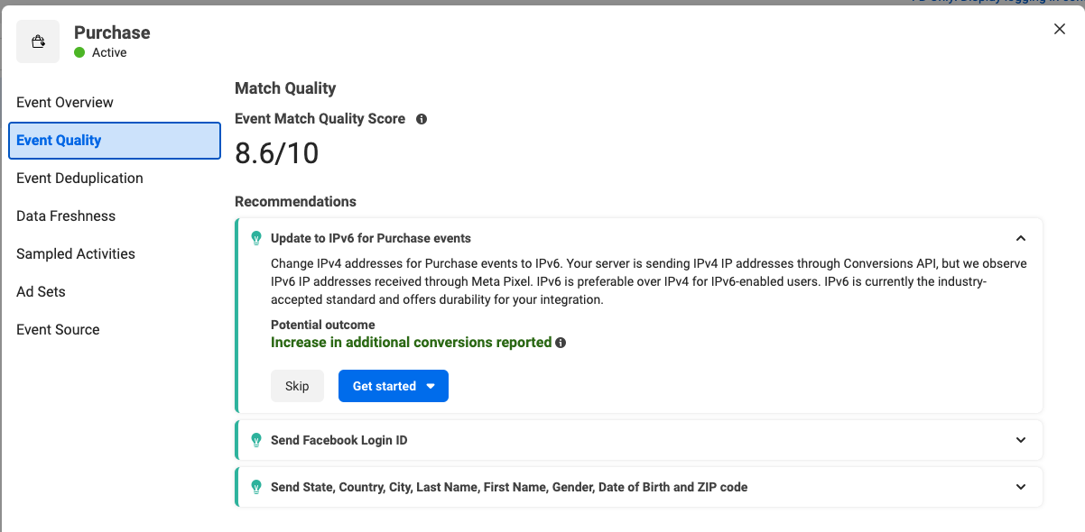

As an alternative to Events Manager, you can use the Integration Quality API to check EMQ scores. For more about this API and how to maximize EMQ, see the documentation here.

Benefits of Offline Data Quality
Improving offline data quality is crucial for enhancing your omnichannel ads, optimized for both online and in-store sales.

The value of offline data quality in enabling omnichannel ads.
Focusing on offline data quality is valuable for your omnichannel advertising strategy:
- Enhanced ad performance: High scores ensure accurate, up-to-date data for precise targeting across channels.
- Accurate measurement: Robust scores enable precise attribution of offline conversions, crucial for understanding ad impact and refining strategies.
- Optimized campaigns: Scores of 8.5 or higher allow confident use of omnichannel ads, ensuring ads reach the right audience at the right time.

Example: Improving offline data quality in retail
A retailer with a score of 6 out of 10 can improve by:
- Increasing data upload frequency: Upload data more regularly.
- Improving data accuracy: Reduce errors and inconsistencies
- Enhancing attribution: Provide all recommended match keys to maximize offline conversion measurement accuracy
Addressing these areas can boost the score, leading to better advertising results, such as increased purchases and improved targeting.
Meta provides personalized recommendations in Events Manager to improve your offline data quality score.

Improve Offline Data Quality
To improve your offline data quality metric:
- Upload fresh data regularly for accurate targeting and measurement.
  - Upload data daily
    - Ensure offline transaction data is not stale (older than 3 days)
- Implement robust data validation processes to minimize errors and inconsistencies.
  - Pass correct purchase prices (for example, no zero or negative values).
  - Avoid linking incorrect dataset IDs to omni campaigns. Note: Use only one offline signal source for omni campaign optimization. For measurement (ad tracking level), an advertiser can attach multiple offline signal sources, but not for ad set level optimization.
- Enable automatic tracking for offline events to accurately attribute offline conversions loads
- Monitor your data collection and processing procedures to maintain high-quality data.
- Regularly review your offline data quality scores in Events Manager and follow your personalized recommendations to improve your offline data quality score.

Data Freshness
Prioritize sharing events in real time for better campaign optimization. Ensure there is little to no delay from when your events occur to when you share them with Meta. This will help to:
- Run ads that are better optimized by having real-time data to update your. audiences
- See the results of an ad campaign closer to real time in Meta Ads Manager.

Website Events
For web events, it is essential to transmit data in real-time for optimal performance. The Meta Pixel and the Conversions API are the most effective methods for sending event data in real-time.
To assess your current status, navigate to Events Manager > Pixel ID > Event Name > View Details > Data Freshness > Website
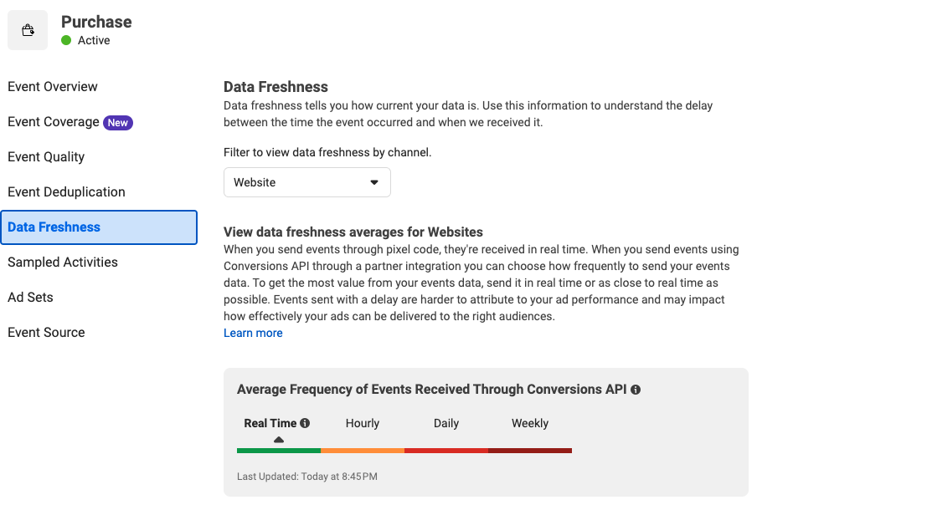

Offline Events
For offline events, it is recommended to send data as frequently as possible as it would help our algorithms to drive performance real/near realtimes. Recommendation is to pass back offline data at least daily and preferably on an hourly basis. To assess your current status, navigate to Events Manager > Pixel ID > Event Name > View Details > Data Freshness > Offline Activity.
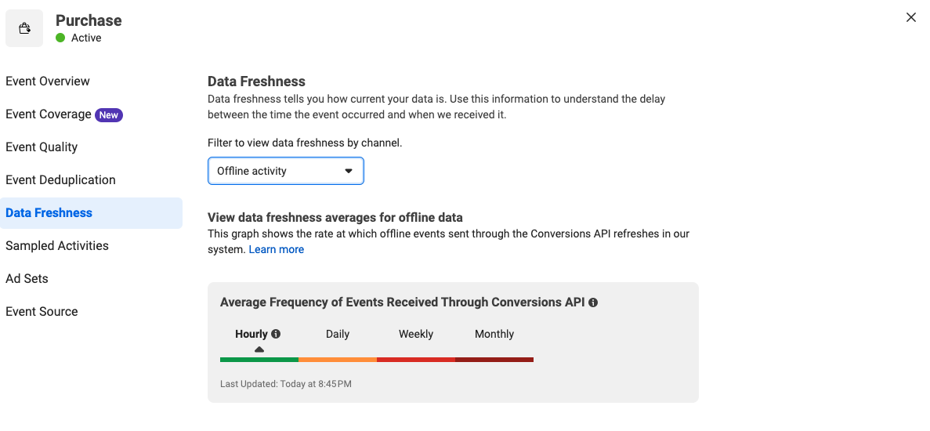

Deduplication
The Meta Pixel and the Conversions API let you share standard and custom events with us so that you can measure and optimize ad performance. The pixel lets you share web events from a web browser, while the Conversions API lets you share web events directly from your server.
If you connect website activity using both the pixel and the Conversions API, we may receive the same events from the browser and the server. If we know that the events are the same and therefore redundant, we can keep one and discard the rest. This is called deduplication.
It is highly recommended to include deduplication parameters with your events to ensure that our systems can accurately identify and process events only once. This is crucial for accurate attribution and measurement purposes.

Web Events
When sending redundant events using the Meta Pixel and Conversions API, ensure that both events use the identical event_name and that either event_id or a combination of external_id and fbp are included. We recommend including all of these parameters to help Meta properly deduplicate events and reduce double reporting of identical events. Maximum deduplication window is 48 hours.

Offline Events
Unlike deduplication set up across the Conversions API and Meta Pixel events, offline events can only be deduplicated against other offline events. We support two methods of deduplication:
- order_id based
- user based
The deduplication uses the combination of fields: dataset_id, event_time, event_name, item_number, and either order_id or user information as the “key field” based on method in the given event’s payload.
The default deduplication uses order_id with a combination of the fields above. If order_id is not present in the payload, the user based deduplication logic will be used. The maximum deduplication window is 7 days. You can learn more about offline event deduplication on our developer documentation site.
It's recommended not to split your order into multiple events instead of sending one event to represent the whole order.
For example, where there are two orders with identical event_time, event_name having the same order_id or same set of Customer Information Parameters without order_id, we will consider them duplicate events and take the first event. The user-based deduplication method only works with the same Customer Information Parameters fields in the two payloads.
Another way to to maximize PII capture rate is in your store. By sending email transactions that capture PII (including receipts), you can increase the event volume to power performant optimization on Meta’s platforms.

Event Quality
Event quality measures the correctness of the parameters in events received from event sources connected to a catalog. Low Event Quality impacts match rate, availability, and can result in longer learning phases and suboptimal campaign optimisation. Please note that these parameters are highly recommended to be passed back via Web and Offline events.
Some of the important parameters that need to be passed are:
1. Content IDs
Tell Meta the specific content ID for a product or product group. The content ID must exactly match either the product ID or the product group ID for that item in your catalog, depending which content_type you entered. The match indicates it's the same product or group as the one in your catalog. Example: ['123','456']
2. Contents (recommended way of sending content details)
Tell Meta the specific content ID, which must match the product ID for that item in your catalog. If you use contents in your parameter, you must also include the following in a sub-object: the product id or ids, and the quantity (number of items added to cart or purchased).
Example: [{id: '123', quantity: 2}, {id: '456', quantity: 1}]. This is our recommended way of passing this information back.
3. Content Type
Should be set to product or product_group:
- Use product if the keys you send represent products. Sent keys could be content_ids or contents.
- Use product_group if the keys you send in content_ids represent product groups. Product groups are used to distinguish products that are identical but have variations such as color, material, size or pattern.
4. Currency
Required for purchase events. The currency for the value specified, if applicable. Currency must be a valid ISO 4217 three-digit currency code.
5. Value
Required for purchase events. A numeric value associated with this event. Please make sure that value >= 0.

Catalog Setup
A catalog is a container that holds information about all the items advertisers want to advertise or sell on Facebook and Instagram. Catalogs are a fundamental building block of several of our available products, including (but not limited to):
- Advantage+ Shopping Campaigns
- Collaborative ads
- Collection ads
- Carousel ads
- Shops
To ensure a quality setup for your catalog for omnichannel ads, please ensure the following areas are covered and optimal:

Catalog Match Rates
A catalog match occurs when an event has been matched with a product. The success rate of this is known as the catalog match rate. Optimal catalog match rates are > 90%

Website Events
To check catalog match rates for web events go to Commerce Manager > Select Catalog > Events > Select datasource (dataset or app).
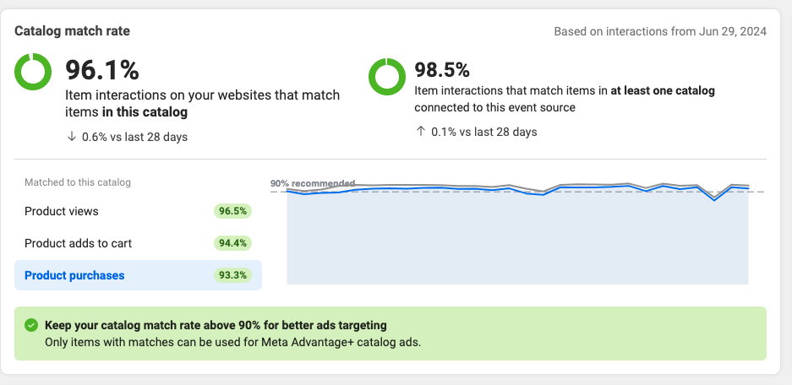

Offline Events
Offline events should be integrated through the API (manual uploading is available but in order to use Omnichannel Ads Beta, CAPI or OCAPI integration is required).
- Frequency of upload:
  - Upload data daily, at least 12 times in the previous 14 days.
    - Ensure offline transaction data is not stale (older than 3 days).
- Offline events data must be passed for the past 14 days to be eligible for Omnichannel Ads.
- Avoid basket splitting your offline events integration by ensuring you pass all items from the same transaction as the same row / basket. This ensures measurement accuracy of Average Order Value and Cost Per Purchase.

Connecting Catalog with Dataset
Please verify that the data source (dataset/app) is properly linked to the catalog. If not, please follow the steps below to establish a connection between the dataset/app and the catalog.
- Go to Commerce Manager
- Select events
- Click on Manage Connections
- Select the dataset ID/app
- Click Save

Enabling Auto-Tracking for Dataset
Auto tracking for dataset allows any future campaigns in that ad account to be automatically tracked via dataset. This is important for campaign attribution. To enable auto tracking please follow these steps.
To add dataset tracking to existing campaigns, go to ad setup and enable tracking inside tracking specs.
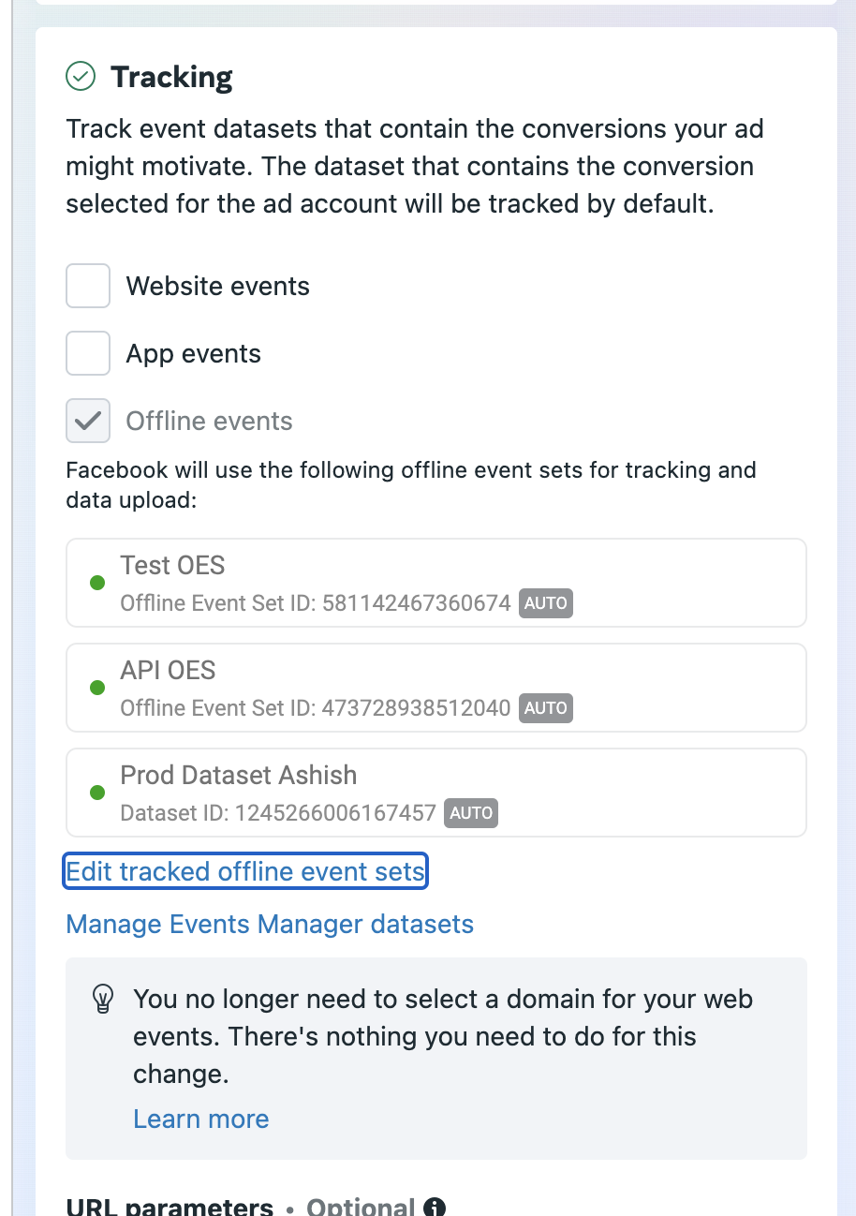

Omni Audience
Omni Audience is a special targeting solution that allows advertisers to create audiences based on user activity across multiple channels.
For example, if an advertiser wants to create an audience of people who viewed a product on their website and then went to the store to purchase, it's possible using this type of audience.

Best Practices and Requirements
Match Rates: Event match rates are crucial in determining the audience size. It is essential to have high match rates for offline events and optimal EMQ scores for web events to ensure decent audience size.
Data Freshness: As Omni Audiences are created based on user actions happening across channels, getting data with less delay would make the audience more recent and accurate.

Learn More
- Conversions API Customer Information Parameters
- Sending Offline Events Using the Conversions API
- Enable Auto-Tracking for Offline Event Sets in Meta Events Manager
- Integration Quality API

Manage Your Ad Object's Status
Ad Campaign, Ad Set and Ads have one of following status types:
- Live
- Archived
- Deleted
For background see Ads Developer Blog, Deleted versus Archived.

Live
Live ad objects can have the following status:
- ACTIVE
- PAUSED
- PENDING_REVIEW
- CREDIT_CARD_NEEDED
- PREAPPROVED
- DISABLED
- PENDING_PROCESS
- WITH_ISSUES

Archived
Set the ad object to ARCHIVED by setting status field to ARCHIVED. When an object status is set to ARCHIVED, you can continue to query the details and stats based on the object id. However there is a maximum limit on the number of objects you can archive. So you should respect this limit and change status to DELETED when you no longer need an object.
An ARCHIVED object has only 2 fields you can change: name and status. You can also only change status to DELETED.

Deleted
Set the ad object to DELETED by either setting status field to DELETED or sending an HTTP DELETE to that object. Once an object status is set to DELETED, you cannot set it back to ARCHIVED.
If you keep the deleted object ID, you can continue to retrieve stats or object details by querying the object ID. However you cannot retrieve the deleted objects as a connection object from a non deleted node or object. For example, <API_VERSION>/<AD_ID>/insights works for a deleted object but <API_VERSION>/act_<AD_ACCOUNT_ID>/insights?level=ad does not return stats for the deleted object.
After you delete an ad, it may still track impressions, clicks, and actions for 28 days after the date of last delivery. You can query insights for DELETED objects using the ad.effective_status filter.
If you have an ad set with 2 ads in it, and you delete one ad, the following 2 queries do not return the same results:
https://graph.facebook.com/v24.0/<AD_SET_ID>/insights
https://graph.facebook.com/v24.0/<AD_ID>/insights
The ad set returns stats for both the deleted and the non-deleted ads in it. However when you query for ads in the ad set, you only see one ad:
https://graph.facebook.com/v24.0/<AD_SET_ID>/ads
To avoid this scenario, you should delete ads 28 days after their last date of delivery to ensure stats no longer change. Also you should store the stats or ids of those objects in your own system before you delete them. This recommendation is optional:
- If your application does not show the breakdown of stats, or
- You do not care if the sum of breakdowns of stats do not match that of the parent object, due to some deleted child objects.
You cannot change any field, except name, for a DELETED object.

Manage Status
This is how you typically manage object status:
- You create ad objects, they run and start delivering
- When you delete an object, we automatically delete it
- When you reach the limit for achieved objects, you can no longer archive more objects.
- You should move archived deleted objects to the deleted state to reduce the limit.
The status on ad objects works this way for the hierarchy of ad objects:
- If the status of a campaign is set to with_issues, paused, archived, or deleted for a campaign, all the objects below it automatically inherit that status.
- If you set an ad campaign to deleted, you cannot retrieve the ad sets or ads below that campaign without explicitly specifying the IDs.
- If the status of an ad is set to with_issues, paused, archived, or deleted, the ad set or ad campaign containing that ad keep its original status and is available for retrieval.
The following limits apply to ARCHIVED objects for given ad account:
- 100,000 for Ad Campaigns
- 100,000 for Ad Sets
- 100,000 for Ads
If you read archived edges, you must specifically filter for the archived objects since we do not return them by default. If you read stats for an ad object, we include the stats of all children objects, no matter if the child is active, archived, or deleted. Therefore you need no filter for insights on child objects.

Comparisons of Different Statuses
Objects with statuses such as ACTIVE, PAUSED differ from those with ARCHIVED status, and DELETED. Here are the major differences.
Query | Live | ARCHIVED | DELETED
Exists in database | Yes | Yes | Yes
Maximum number per ad account | With limits | 100,000 | No limit
Query as edges without filter | Yes | No | No
Query as edges with status filter | Yes for objects of status contained in the filter | Yes if status filter contains ARCHIVED. | No if status filter does not contain DELETED, and error if it does.
Query by its own ID | Yes | Yes | Yes
Stats aggregated in /<PARENT_OBJECT_ID>/insights | Yes | Yes | Yes
Stats included in the result list of /<PARENT_OBJECT_ID>/insights?level=<OBJECT_LEVEL> | Yes | No | No
Stats included in the result list of /<PARENT_OBJECT_ID>/insights with delivery_info filtering | Yes for objects of status contained in the filter | Yes for objects of status contained in the filter | No
Insights shown with /<OBJECT_ID>/insights | Yes | Yes | Yes
Status can be changed to | Any valid status | DELETED | Cannot change
To set an ad to be archived:
curl -X POST \
-d "status=ARCHIVED" \
-d "access_token=<ACCESS_TOKEN>" \
https://graph.facebook.com/v24.0/<AD_ID>
To delete an ad:
curl -X POST \
-d "status=DELETED" \
-d "access_token=<ACCESS_TOKEN>" \
https://graph.facebook.com/v24.0/<AD_ID>
To retrieve live subobjects of a live object, for example, all live ads of an ad campaign, not including ARCHIVED or DELETED ads:
curl -X GET \
-d 'fields="name"' \
-d 'access_token=<ACCESS_TOKEN>' \
https://graph.facebook.com/v24.0/<AD_CAMPAIGN_ID>/ads
To retrieve ARCHIVED subobjects of a live object, for example, all ARCHIVED ads of an ad set, requires the status filter:
curl -X GET \
-d 'effective_status=[
"ARCHIVED"
]' \
-d 'fields="name"' \
-d 'access_token=<ACCESS_TOKEN>' \
https://graph.facebook.com/v24.0/<AD_CAMPAIGN_ID>/ads

Asynchronous and Batch Requests
Use asynchronous requests to create ads and send numerous ads requests without having to block. Either specify a URL to call after requests complete or check the status of the request. See Ad, Reference.
The most efficient way to manage ads is via batched requests. Use it to perform some of the more common requests.

Asynchronous Requests
For example, get the status of the asynchronous request set:
curl -G \
-d 'fields=name,success_count,error_count,is_completed' \
-d 'access_token=<ACCESS_TOKEN>' \
https://graph.facebook.com/v24.0/<REQUEST_SET_ID>
This returns the overall status for the async request set as a JSON object. Not all fields appear by default. If you want your query to include non-default fields, specify them in fields, such as fields=id,owner_id,name,total_count,success_count,error_count,is_completed.
Name | Description
id  type: int | Shown by default.  The id of current async request set.
owner_id  type: int | Shown by default.  Which object owns this async request set. For async requests on ads, owner_id is the account id.
name  type: string | Shown by default.  Name of this async request set.
is_completed  type: boolean | Shown by default.  Async requests in this set complete
total_count  type: int | Not shown by default.  Total requests count of this request set
initial_count  type: int | Not shown by default.  Number of requests not yet served.
in_progress_count  type: int | Not shown by default.  Number of requests in progress.
success_count  type: int | Not shown by default.  Number of requests finished and successful.
error_count  type: int | Not shown by default.  Number of requests finished and failed.
canceled_count  type: int | Not shown by default.  Number of requests canceled by user
notification_uri  type: string | Not shown by default.  Notification URI for this async request set.
notification_mode  type: string | Not shown by default.  Way to receive notification. Valid values include:  - OFF – No notifications  - ON_COMPLETE – Send notification when whole set finished.
After you get the overall status of the async request set, get details of each request:
curl -G \
-d 'fields=id,status' \
-d 'access_token=<ACCESS_TOKEN>' \
https://graph.facebook.com/v24.0/<REQUEST_SET_ID>/requests
This returns status and details of each request inside the async request set. For async ad creation, make one request to create one ad. The status param is used to filter requests by its own status and can be any combination of following values:
- initial – Not processed yet.
- in_progress – Request is processing
- success – Request finished and succeeds.
- error – Request finished and failed
- canceled – Request canceled by user
The response is a JSON array with default fields. To include any non-default field, specify it in fields, such as fields=id,scope_object_id,status,result,input,async_request_set.
Name | Description
id  type: int | Shown by default.  Individual async request ID
scope_object_id  type: int | Shown by default.  Parent id of object this request creates. If you create an ad, this is ad set ID for the new ad.
status  type: string | Shown by default.  Status of this async request. Options:  - Initial – Not processed yet  - In_progress – Request is processing  - Success – Request finished and succeeds  - Error – Request finished and failed  - Canceled – Request is canceled by user
result  type: array | Not shown by default.  If request is finished, shows result of the request.  On success, the result is the same as a non-async request. For example, if you create an ad, the result for each request is the ID of the new ad. For errors, it will be array of:  - error_code – Error code returned  - error_message – Error message
input  type: object | Not shown by default.  Original input for this async request. If you create an ad, the input is adgroup_spec.
async_request_set  type: object | Not shown by default.  Async request set that contains this individual request

Get Request Details
To get details of a specific async request, make this call:
curl -G \
-d 'fields=id,status' \
-d 'access_token=<ACCESS_TOKEN>' \
https://graph.facebook.com/v24.0/<REQUEST_SET_ID>/requests
This returns a JSON object with fields listed above.

List Request Sets for an Account
You can create multiple async ad request sets. To query all async ad request sets for an ad account:
curl -G \
-d 'access_token=<ACCESS_TOKEN>' \
https://graph.facebook.com/v24.0/act_<AD_ACCOUNT_ID>/asyncadrequestsets
This returns a JSON array of async request set objects. Each object is the same as specified in async request set section. You can filter results with is_completed. If is_completed=true, you see only completed async request set.

List Requests for an Ad Set
You can make an async call to create ads in different ad sets. To get the status for each ad set, get all ad creation requests for one ad set:
curl -G \
-d 'fields=id,status' \
-d 'access_token=<ACCESS_TOKEN>' \
https://graph.facebook.com/v24.0/<AD_SET_ID>/asyncadrequests
This returns a JSON array of async request objects. The status, fields filter and async request fields are the same as https://graph.facebook.com/&lt;API_VERSION>/&lt;REQUEST_SET_ID>/requests API.

Update Request Sets
You can change name, notification_uri and notification_modefor an async request set.
curl \
-F 'name=New Name' \
-F 'notification_mode=OFF' \
-F 'access_token=<ACCESS_TOKEN>' \
https://graph.facebook.com/v24.0/<REQUEST_SET_ID>
This return true on successful update. You can only change notification_uri and notification_mode before the notification is sent.

Cancel Request
You can cancel an async request, but the request can only be cancelled if it is not processed yet.
curl -X DELETE \
-d 'access_token=<ACCESS_TOKEN>' \
https://graph.facebook.com/v24.0/<REQUEST_ID>
Returns true on successful cancellation. You can also cancel unprocessed requests in the async request set:
curl -X DELETE \
-d 'access_token=<ACCESS_TOKEN>' \
https://graph.facebook.com/v24.0/<REQUEST_SET_ID>
Returns true on successful cancellation.

Async Examples
Getting status of a specific async request:
//pretty=true for command line readable output
curl -G \
-d "id=6012384857989" \
-d "pretty=true" \
-d "access_token=_____" \
"https://graph.facebook.com/v24.0/"
Return values:
{
"id": "6012384857989",
"owner_id": 12345,
"name": "testasyncset",
"is_completed": true
}
Get results of requests:
curl -G \
-d "id=6012384857989" \
-d "pretty=true" \
-d "fields=result" \
-d "access_token=_____" \
"https://graph.facebook.com/v24.0/requests"
Returns:
{
"data": [
{
"result": {
"id": "6012384860989"
},
"id": "6012384858389"
},
{
"result": {
"id": "6012384858789"
},
"id": "6012384858189"
}
],
"paging": {
"cursors": {
"after": "___",
"before": "___"
}
}
}
Get list of request sets for an ad account:
curl -G \
-d "is_completed=1" \
-d "pretty=true" \
-d "access_token=___" \
"https://graph.facebook.com/v24.0/act_71597454/asyncadrequestsets"
Returns:
{
"data": [
{
"id": "6012384253789",
"owner_id": 71597454,
"name": "testasyncset",
"is_completed": true
},
],
"paging": {
"cursors": {
"after": "___",
"before": "___"
}
}
}
Getting a list of requests for a campaign:
curl -G \
-d "status=SUCCESS,ERROR" \
-d "pretty=true" \
-d "access_token=___" \
"https://graph.facebook.com/v24.0/6008248529789/asyncadrequests"

Return values:
{
"data": [
{
"id": "6012384951789",
"scope_object_id": 6008248529789,
"status": "SUCCESS"
},
],
"paging": {
"cursors": {
"after": "___",
"before": "___"
}
}
}

Batch Requests
With batched requests, combine a number of Graph API calls into the one HTTP request. Marketing API split this request into its constituent requests. This makes batched requests the most efficient way of interacting with the Marketing API. For even greater efficiency you can make parallel batch requests using separate processing threads.
Each batched request can contain a maximum of 50 requests. For ad creation you should only have 10 or less ads per batch.
Batch requests for ads, adcreatives and ad sets are very similar so we don't discuss them separately here. For more information, see Graph API batch requests and ETags.

Create Ads
You can provide adcreative and other ad objects in a batched request. For example, you can create three ads using one adcreative and three different targeting specs. Define your Ad Creative first then reference it when you create each ad:
curl -F 'access_token=______'
-F 'test1=@./test1.jpg'
-F 'batch=[
{
"method": "POST",
"name": "create_adimage",
"relative_url": "<API_VERSION>/act_187687683/adimages",
"attached_files": "test1"
},
{
"method": "POST",
"name": "create_creative",
"relative_url": "<API_VERSION>/act_187687683/adcreatives",
"attached_files": "test1",
"body": "name=sample creative&object_story_spec={\"link_data\": {\"image_hash\": \"{result=create_adimage:$.images.*.hash}\", \"link\": \"https://www.test12345.com\", \"message\": \"this is a sample message\"}, \"page_id\":\"12345678\"}&degrees_of_freedom_spec={\"creative_features_spec\": {\"standard_enhancements\": {\"enroll_status\": \"OPT_OUT\"}}}"
},
{
"method": "POST",
"relative_url": "<API_VERSION>/act_187687683/ads",
"body": "adset_id=6004163746239&redownload=1&status=PAUSED&optimization_goal=REACH&billing_event=IMPRESSIONS&&creative={\"creative_id\":\"{result=create_creative:$.id}\"}&targeting={\"countries\":[\"US\"]}&name=test1"
},
{
"method": "POST",
"relative_url": "<API_VERSION>/act_187687683/ads",
"body": "adset_id=6004163746239&redownload=1&status=PAUSED&optimization_goal=REACH&billing_event=IMPRESSIONS&&creative={\"creative_id\":\"{result=create_creative:$.id}\"}&targeting={\"countries\":[\"US\"]}&name=test2"
},
{
"method": "POST",
"relative_url": "<API_VERSION>/act_187687683/ads",
"body": "adset_id=6004163746239&redownload=1&status=PAUSED&optimization_goal=REACH&billing_event=IMPRESSIONS&&creative={\"creative_id\":\"{result=create_creative:$.id}\"}&targeting={\"countries\":[\"US\"]}&name=test3"
}
]' https://graph.facebook.com/
The response includes individual response codes for each request and the standard Graph API response. For details, see Making Multiple API Requests.
The batched request process uses the JSONPath expression format to reference the previous requests.

Update Ads
You can update ads with batch requests. To updates bids for three ads:
curl -F 'access_token=____'
-F 'batch=[
{
"method": "POST",
"relative_url": "<API_VERSION>/6004251715639",
"body": "redownload=1&name=new name"
},
{
"method": "POST",
"relative_url": <API_VERSION>/v6004251716039",
"body": "redownload=1&name=new name"
},
{
"method": "POST",
"relative_url": "<API_VERSION>/6004251715839",
"body": "redownload=1&name=new name"
}
]' https://graph.facebook.com
If you include redownload=1 in the relative URL, you get full ad details including the ad ID. This help identify which ads you updated.
To update ad creative, specify the entire creative, or provide a new creative ID. This is because Ad Creatives cannot be edited after they have been created except for name and run status.

Read Ads
If you have a large number of ads, split the request over multiple requests within a batched request:
curl -F 'access_token=____'
-F 'batch=[
{
"method": "GET",
"relative_url": "<API_VERSION>/?ids=6003356308839,6004164369439&fields=<comma separated list of fields>"
},
{
"method": "GET",
"relative_url": "<API_VERSION>/6003356307839/ads&fields=<comma separated list of fields>"
},
{
"method": "GET",
"relative_url": "<API_VERSION>/act_187687683/ads?adset_ids=[6003356307839, 6004164259439]&fields=<comma separated list of fields>"
}
]' https://graph.facebook.com
6003356308839 and 6004164369439 are ad ids and 6003356307839 and 6004164259439 are ad set ids.

Ad Insights
If you have a large number of Ad Insights split the request over multiple requests within a batched request:
curl -F 'access_token=____'
-F 'batch=[
{
"method": "GET",
"relative_url": "<API_VERSION>/act_19643108/insights?filtering=[{field:'ad.id',operator:'IN',value:[6003356308839,6004164369439]}]"
},
{
"method": "GET",
"relative_url": "<API_VERSION>/6003356308839/insights"
},
{
"method": "GET",
"relative_url": "<API_VERSION>/act_187687683/insights?filtering=[{field:'adset.id',operator:'IN',value:[6003356307839, 6004164259439]}]"
}
]' https://graph.facebook.com
In this example 6003356308839 and 6004164369439 are ad ids and 6003356307839 and 6004164259439 are ad set ids.
For Ad accounts with a large number of ads using act_<account_ID>/adgroupstats is not recommended as it may cause the request to timeout.

Batch requests for Reach Estimate
You can request up to 50 reach estimates in a single batched request. The following example shows the reach estimate being requested for 2 different targeting specs:
curl -F 'access_token=____'
-F 'batch=[
{
"method": "GET",
"relative_url": "<API_VERSION>/act_600335/reachestimate?targeting_spec={'geo_locations': {'countries':['US']}}"
},
{
"method": "GET",
"relative_url": "<API_VERSION>/act_600335/reachestimate?targeting_spec={'geo_locations': {'countries':['FR']}}"
}
]' https://graph.facebook.com

Batch API
Batch API enables you batch requests and send them asynchronously. Group several Graph API calls into one HTTP request, and execute them asynchronously without having to block. You can also specify dependencies between related operations.
Facebook processes each independent operation in parallel processes and your dependent operations sequentially. Each API call can have a maximum of 1000 requests.

Make a Batch API call
To make a Batch API call:
curl \
-F "access_token=___" \
-F "name=asyncbatchreqs" \
-F "adbatch=<an array of requests>"\
"https://graph.facebook.com/v24.0/act_<AD_ACCOUNT_ID>/async_batch_requests"
Provide an array of HTTP POST requests as JSON arrays. Each request has:
- name
- relative_url - portion of URL after graph.facebook.com
- body
The API returns an id you use to query the progress of requests.
For example, create a campaign with an ad set with JSONPath Format to reference the previous requests:
curl \
-F "access_token=___" \
-F "name=batchapiexample" \
-F "adbatch=[
{
'name': 'create-campaign',
'relative_url': 'act_123456/campaigns',
'body': 'name%3DTest+Campaign%26objective%3DLINK_CLICKS%26status%3DPAUSED%26buying_type%3DAUCTION',
},
{
'name': 'create-adset',
'relative_url': 'act_123456/adsets',
'body': 'targeting%3D%7B%22geo_locations%22%3A%7B%22countries%22%3A%5B%22US%22%5D%7D%7D%26daily_budget%3D5000%26campaign_id%3D%7Bresult%3Dcreate-campaign%3A%24.id%7D%26bid_amount%3D2%26name%3DFirst%2BAd%2BSet%20Test%26billing_event%3DLINK_CLICKS',
},
]" \
https://graph.facebook.com/<API_VERSION>/act_123456/async_batch_requests
To get a request set status:
curl –G \
-d "access_token=___" \
-d "fields=<comma separated list of fields>" \
"https://graph.facebook.com/v24.0/<REQUEST_SET_ID>"
This returns overall status for async request sets as JSON objects. Not all fields are returned by default. To include them, specify the fields, such as fields=id,owner_id,name,total_count,success_count,error_count,is_completed
Name | Description
id  type: int | Shown by default.  id of current async request set.
owner_id  type: int | Shown by default.  Object that owns this async request set. If you create ads, owner_id is the ad account id.
name  type: string | Shown by default.  Name of this async request set
is_completed  type: boolean | Shown by default.  All async requests in set complete
total_count  type: int | Not shown by default.  Total requests count for this request set
initial_count  type: int | Not shown by default.  Number of requests not served yet
in_progress_count  type: int | Not shown by default.  Number of requests in progress
success_count  type: int | Not shown by default.  Number of requests finished and successful
error_count  type: int | Not shown by default.  Number of requests finished and failed
canceled_count  type: int | Not shown by default.  Number of requests canceled by user
notification_uri  type: string | Not shown by default.  Notification URI for this async request set.
notification_mode  type: string | Not shown by default.  Ways to receive notification. Valid values:  - OFF – No notifications  - ON_COMPLETE – Send notification when the whole set done.
notification_result  type: string | Not shown by default.  Result of sending notification.
notification_status  type: string | Not shown by default.  Notification status: not_sent, sending, or sent
After you get overall status, you can get details for each request:
curl –G \
-d "access_token=___" \
-d "fields=<comma separated list of fields>" \
"https://graph.facebook.com/v24.0/<REQUEST_SET_ID>/requests"
This returns details as a JSON array. To include non-default fields, specify it in fields, such as fields=id,scope_object_id,status,result,input,async_request_set.
Name | Description
id  type: int | Shown by default.  ID of individual async request
scope_object_id  type: int | Shown by default.  Parent ID of the object this request creates. If you create ads, this is ad set ID for the new ad.
status  type: string | Shown by default.  Status of this async request:  - Initial – Not processed yet  - In_progress – Request is processing  - Success – Request finished and successful  - Error – Request finished and failed  - Canceled – Request canceled by user
result  type: array | Not shown by default.  If request finishes, show result. For success, the result is same as non-async API. For example, if you create an ad creation, result is new ad ID. For errors:  - error_code – Error code returned  - error_message – Error message
input  type: object | Not shown by default.  Original input for this request. If you create an ad, the input is adgroup_spec.
async_request_set  type: object | Not shown by default.  Async request set containing this request.

List Batch API Requests for Ad Account
You can create multiple Batch API request sets. To query all request sets under an ad account:
curl –G \
-d "access_token=___" \
"https://graph.facebook.com/v24.0/act_<AD_ACCOUNT_ID>/async_requests"

ETags
Marketing API supports Etags. This helps you tell if the data you query has changed since you last checked. How this works:
- When you make a call, the response header includes an ETag with a value that is the hash of the data returned in the API call. Save this ETag value for use in the next step.
- Next time you make the same API call, include the If-None-Match request header with the ETag value you saved.
- If the data has not changed, the response status code is 304 – Not Modified and no data is returned.
- If the data has changed since the last query, the data is returned as usual with a new ETag. Save the new ETag value and use it for subsequent calls.
While ETags help reduce data traffic, If-None-Match GET still counts against rate limits for your app.
The ETag is calculated using the entire response from the API call including its formatting. The formatting of the response may be impacted by the user agent string. Therefore, you should keep your user agent consistent between calls made from the same client.

Etags Examples
To check if the user's adaccounts have changed.
Step 1: Determine the ETag for the current data
curl -i "https://graph.beta.facebook.com/me/adaccounts?access_token=___"
The response will be as follows:
HTTP/1.1 200 OK
Access-Control-Allow-Origin: *
Cache-Control: private, no-cache, no-store, must-revalidate
Content-Type: text/javascript; charset=UTF-8
ETag: "7776cdb01f44354af8bfa4db0c56eebcb1378975"
Expires: Sat, 01 Jan 2000 00:00:00 GMT
Pragma: no-cache
X-FB-Rev: 495685
X-FB-Server: 10.30.149.204
X-FB-Debug: CWbHcogdwUE8saMv6ML+8FacXFrE8ufhjjwxU2dQWaA=
X-Cnection: close
Date: Mon, 16 Jan 2012 12:07:44 GMT
Content-Length: 3273

{"data":[{"id":"act.......
In this example the ETag is "7776cdb01f44354af8bfa4db0c56eebcb1378975", note that the ETag includes the quotes (").
Step 2: Determine if there have been any changes to the data
curl -i -H "If-None-Match: \"7776cdb01f44354af8bfa4db0c56eebcb1378975\"" "https://graph.beta.facebook.com/me/adaccounts?access_token=___"
If nothing has changed the response will be as follows:
HTTP/1.1 304 Not Modified
Access-Control-Allow-Origin: *
Cache-Control: private, no-cache, no-store, must-revalidate
Content-Type: text/javascript; charset=UTF-8
Expires: Sat, 01 Jan 2000 00:00:00 GMT
Pragma: no-cache
X-FB-Rev: 495685
X-FB-Server: 10.30.177.190
X-FB-Debug: ImBhat3k07Nez5FvuS2lPWU0U2xxmxD4B3k9ua4Sk7Q=
X-Cnection: close
Date: Mon, 16 Jan 2012 12:09:17 GMT
Content-Length: 0
Note the 304 Not Modified response. If the data had changed a normal API response would be returned.
A batch example to check if the user's ads have changed.
Step 1: Determine the ETag for the current data
curl -i "curl -F 'access_token=___' -F 'batch=[
{"method":"GET", "relative_url": "?ids=6003356308839,6004164369439" },
{"method":"GET", "relative_url": "act_12345678/ads?campaign_ids=[6003356307839, 6004164259439]"}]'
https://graph.facebook.com"
The response will contain ETag values as follows:
...{"name":"ETag","value":"\"21d371640127490b2ed0387e8af3f0f8c9eff012\""}...
...{"name":"ETag","value":"\"410e53bb257f116e8716e4ebcc76df1c567b87f4\""}...
In this example the ETags are "21d371640127490b2ed0387e8af3f0f8c9eff012" and "410e53bb257f116e8716e4ebcc76df1c567b87f4" note that the ETag includes the quotes (").
Step 2: Determine if there have been any changes to the data:
curl -F 'access_token=___' -F 'batch=[
{"method":"GET", "headers":["If-None-Match: \"21d371640127490b2ed0387e8af3f0f8c9eff012\""], "relative_url": "?ids=6003356308839,6004164369439" },
{"method":"GET", "headers":["If-None-Match: \"410e53bb257f116e8716e4ebcc76df1c567b87f4\""], "relative_url": "act_12345678/ads?campaign_ids=[6003356307839, 6004164259439]"}]'
https://graph.facebook.com
If nothing has changed the response is:
[{
"code": 304,
.
.
.
"body": null
},
{
"code": 304,
.
.
.
"body": null
}]
Note the 304 Not Modified response. If the data changed, we return a normal API response.

Post-Processing for Ad Creation and Edits
Prior to v4.0, ads buying could cause system timeout, out of memory errors or delays. To scale the system, we decoupled logic that requires significant computation and that causes transient errors to an separate workflow called post-processing. Now when you create or edits ads, it is more resilient to transient errors. The process looks like this:
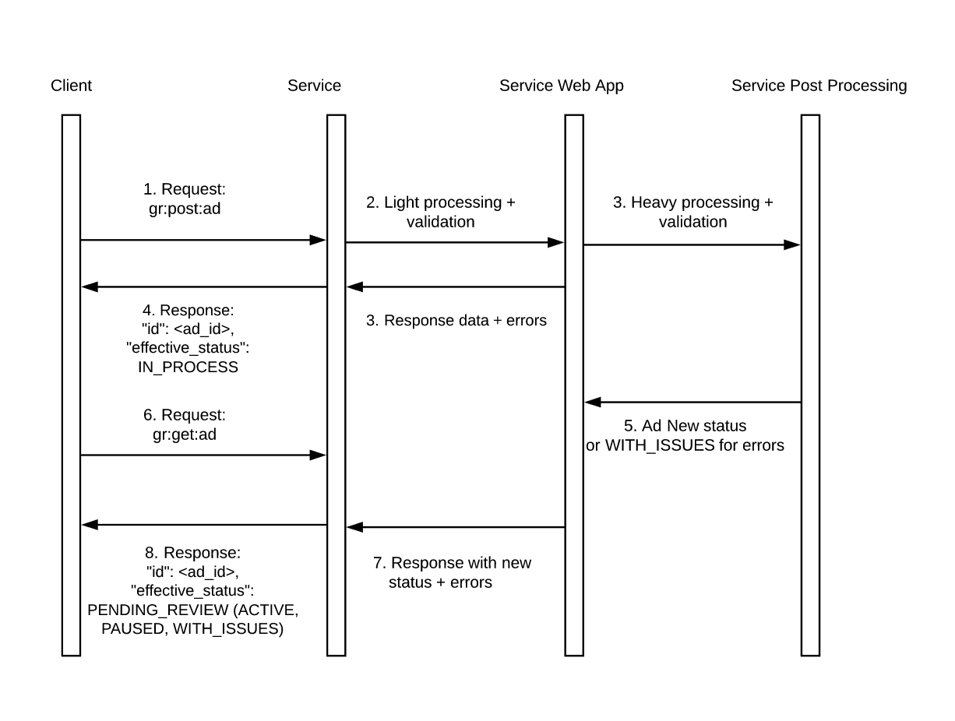
To represent a post processing phase after a request is received, we introduce the ads run status IN-PROCESS in v4.0. This new status applies to:
- {campaign_ID},
- {ad_set_ID},
- {ad_ID} and
- {ad_creative_ID}.
For campaigns, ad sets and ads, this impacts:
Field | v4.0 and above | Below v4.0
effective_status (enum {ACTIVE, PAUSED, DELETED, PENDING_REVIEW, DISAPPROVED, PREAPPROVED, PENDING_BILLING_INFO, CAMPAIGN_PAUSED, ARCHIVED, ADSET_PAUSED, WITH_ISSUES, IN_PROCESS}) | IN_PROCESS | For campaigns or ad sets: configured_status or status. for ads: pending_review.
configured_status enum {ACTIVE, PAUSED, DELETED, ARCHIVED} | No change | No change
status (enum {ACTIVE, PAUSED, DELETED, ARCHIVED}) | No change | No change
The post-processing phase appears in effective_status for campaigns, ad sets and ada, and in the status field for ad creatives. For example, you can query the status of your object at /creative_id?fields=status. If it is in the post-processing phase, you see:
{
"status": "IN-PROCESS",
"id": "<creative_id>"
}
If your ad creative successfully passes post-processing, you see:
{
"status": "ACTIVE",
"id": "<creative_id>"
}
If post-processing fails, we set your object to WITH_ISSUES and provide an error in issues_info. For example, at creative_ID?fields=status, issues_info:
{
"status": "WITH_ISSUES",
"issues_info": [
{
"level": "CREATIVE",
"error_code": 1815869,
"error_summary": "Ad post is not available",
"error_message": "The Facebook post associated with your ad is not available. It may have been removed, or you may not have permission to view it." }
],
"id": "<creative_id>"
}
When ad object is IN_PROCESS, you can still make regular updates to the object and its children.

Troubleshooting
Working with the Marketing API can occasionally present challenges. Below are issues users may encounter, along with practical solutions to help streamline your experience.

Error Handling
Use the error handling techniques and best practices below to enhance the reliability and efficiency of your applications.

Authorization Errors
These errors often occur due to access tokens that are expired, invalid, or lacking the necessary permissions. To mitigate these issues, ensure that tokens are refreshed regularly and that the correct scopes are requested during authorization.

Invalid Parameters
Sending requests with incorrect or missing parameters can lead to errors. Always validate the input data before making API calls. Utilizing validation tools can significantly reduce such errors.

Resource Not Found
This error occurs when attempting to access a resource that does not exist or has been deleted. To resolve this, check that resources (like campaigns or ad sets) exist before performing operations on them.

Rate Limiting
The Marketing API enforces rate limits to prevent abuse. Exceeding these limits results in error messages indicating that too many requests have been made in a short time. Employing exponential backoff strategies can help slow down request rates after hitting the limit.
To optimize performance and avoid hitting rate limits, create a queue system for API requests. This allows for controlled pacing of requests, ensuring compliance with the API's limits without sacrificing performance.

Caching Strategies
Implement caching for frequently accessed data, such as audience insights or ad performance metrics. This reduces the number of API calls and speeds up data retrieval, leading to a more efficient application.

Managing API Versioning
Stay informed about updates and changes in the Marketing API by regularly checking the documentation. Placing API calls within version-specific functions can prepare your application for version changes, allowing for independent updates.

Error Logging and Monitoring
Implement robust error logging to track API interactions. This will help identify patterns in errors and facilitate quicker resolutions. Utilizing monitoring tools can alert developers to critical failures or unusual patterns in API usage.

Transient Issues
Errors will sometimes indicate that the issue is transient (i.e., "is_transient": true). This indicates it might recover or be fixed soon, so it's best to wait and retry later.

Error Codes
The following are error codes returned by the API:
Error Code | Description
- | Negative-value error codes are internal Facebook errors. Check error_subcode for the actual failure code.
1 | An unknown error occurred
1, subcode 99 | An unknown error occurred. This error may occur if you set level to adset but the correct value should be campaign.
4 | Application request limit reached
10 | Application does not have permission for this action
17 | User request limit reached
100 | Invalid parameter
100, subcode 33 | Unsupported post request.  This error may occur if your access token is not added as a system user with appropriate permissions to the ad account that owns a Custom Audience. Verify the ad account in Business Manager and verify all system users appear under the ad account as Admin:  - Click on Business Settings  - Click the ad account  - Select Add people  - Search for system user and add them as Admins  - Retry your API call
100, subcode 1487694 | Invalid parameter.  The category you selected is no longer available. Several behavior-based targeting categories are deprecated. If you try to use them to create ads, your requests fails and returns this error. Use Targeting Search to see categories available for targeting.
100, subcode 1752129 | Invalid parameter.  This Task Combination Is Not Supported. To assign a user for this ad account valid capabilities, you should pass in a combination of tasks defined in the mapping. See Business Manager API, Permitted Roles.
100, subcode 3858258 | Image Wasn't Downloaded.  Your image, <IMAGE_URL>, couldn't be downloaded. Please ensure the image is accessible via the internet and is not blocked by a robots.txt.  The image may not be accessible online or is being blocked by a robots.txt file. Add a disallow to robots.txt for the relevant crawler. See Meta Web Crawlers - The robots.txt file for more information.
102 | Session key invalid or no longer valid
104 | Incorrect signature
190 | Invalid OAuth 2.0 Access Token
200 | Permission error
200, subcode 1870034 | Custom Audience Terms Not Accepted: You'll need to agree to the Custom Audience terms before you can create or edit an audience or an ad set. See Facebook, Custom Audience Terms
200, subcode 1870047 | Audience Size too Low: You cannot remove users from this audience because it will result in a low audience size and may result in under-delivery or non-delivery of your ads.
294 | Managing advertisements requires the extended permission ads_management and an application that is in our allow list to access the Marketing API
2606 | Unable to display a preview of this ad
2607 | The given currency is invalid for usage with ads.
2615 | Invalid call to update this adaccount
2654 | Failed to create custom audience.
2654 subcode 1713092 | No write permission for this ad account. Developer making this call must have permissions for the ad account to create an audience for it.
5000 | Unknown Error Code
1340029 | Currently deletion of Dynamic Creative Ad is not allowed. Please proceed by deleting parent Ad Set
1373054 | No Call To Action Type was parseable. Please refer to the call to action api documentation
1404078 | You have been temporarily blocked from performing this action.
1404163 | You're no longer allowed to use Facebook Products to advertise. You can't run ads, manage advertising assets or create new ad or business accounts. Learn More
1487007 | You can't edit this ad because it's part of a scheduled ad set that has reached its end date. Please go to the Budget and Schedule section of the ad set and change the end date to a date in the future and then try your edits again.
1487033 | Your campaign's end date must be in the future. Please choose a different end date and try again.
1487056 | This ad set has been deleted, so you can only edit the name. If you want to edit other fields, you can duplicate this ad set, which will create a new ad set with the same settings that you can then edit.
1487472 | You are using {msg}, which can't be promoted in an ad. Please choose a different Page post to continue.
1487566 | This campaign has been deleted, so you can only edit the name. If you want to edit other fields, you can duplicate this campaign, which will create a new campaign with the same settings that you can then edit.
1487678 | The app you're trying to create an ad for is on a different operating system than targeting settings for this ad set.
1487831 | Your product set cannot be loaded. It may be non-existent or inaccessible due to privacy reasons.
1487929 | The object you are trying to promote is ambiguous. You must specify only one promoted object.
1487990 | This Ad Account has already too many archived adgroups. You need to delete some of them before being able to archive any more.
1815199 | Ad account has no access to this Instagram account. Please use authorized Instagram account or assign ad account to this Instagram account first.
1815629 | All ad asset values should be unique. Please check your values.
1815694 | The user does not have the permission for this action.
1870065 | This can't be used because it contains at least one audience that was disabled. Disabled audiences were shared by accounts that are no longer active. To fix this issue, remove the affected audiences
1870088 | Connection targeting is being deprecated. Please remove connections from your campaign to publish your campaign.
1870090 | To create or edit audience or ad set, please agree to the Custom Audience terms.
1870092 | To create or edit audience or ad set, please agree to the Meta Business Tools terms
1870165 | Your audience contains targeting options that can no longer be used to target ads to people under 18 globally, 20 in Thailand or 21 in Indonesia. Increase the minimum age of your audience or remove all targeting options apart from location, age and gender.
1870199 | All location targeting will now reach people living in or recently in the locations you selected. Please remove all values from the location_types field.
1870219 | Only employer exclusions are allowed to be saved in account control. If you are trying to save anything other than employer exclusions then this error will be thrown.
1870220 | If you are trying to save more than the allowed number of employer exclusions then this error will be thrown.
1885029 | The Page selected for your ad doesn't match the Page associated with the object you're promoting, like a Page post or app. Please make sure the Pages are the same.
1885088 | This ad has been archived and can not be edited. Only name is allowed to be edited for this ad. If you want to edit other fields, you can duplicate this ad, which will create a new ad with the same settings that you can then edit.
1885183 | Ads creative post was created by an app that is in development mode. It must be in public to create this ad.ate this ad, which will create a new ad with the same settings that you can then edit.
1885204 | You need to set your bid to automatic for the chosen optimization. Remove any billing or bid info or change your optimization.
1885272 | Budget is too low.
1885557 | Your ad is promoting an unavilable post. It is either deleted, unpublished, not owned by the ad's page or you do not have permissions to see or promote it.
1885621 | You can only set an ad set budget or a campaign budget.
1885557 | Your ad is promoting an unavilable post. It is either deleted, unpublished, not owned by the ad's page or you do not have permissions to see or promote it.
1885650 | Your budget is too low. This minimum amount is required to account for any spending that occurs while your budget is updated, which may take up to 15 minutes.
2238055 | You can not pass both instagram_user_id and instagram_actor_id or instagram_story_id and source_instagram_media_id in creative spec
2446149 | You can not pass both instagram_user_id and instagram_actor_id or instagram_story_id and source_instagram_media_id in creative spec
2446307 | Campaign group spend cap is less than minimum
2238055 | Your campaign budget must be at least {minimum_budget} to account for all ad sets in this campaign.
2446173 | Target rule label with name {label} doesn't refer to any of the asset labels. Please fix it by removing all ad creatives.
2446289 | The {post_type} you selected for your ad is not available. It could be deleted or you might not have permissions to see it. Please check your ad creative and try again.
2446347 | The ad of an existing post should have the flag use_existing_post (default rule in "asset_feed_spec:target_rules") set to true. This is part of the POST request to the server, not something that can be done through the UI.
2446383 | Your campaign objective requires an external website URL. Select a call to action and enter a website URL in the ad creative section.
2446394 | This ad set includes detailed targeting options that are either no longer available or aren't available when excluding people from an audience. You may need to remove items from your detailed targeting or confirm the changes to turn it back on.
2446509 | The ad campaign destination type is not valid
2446580 | Cannot specify both components and child_attachments field when providing interactive_components_spec params
2446712 | The ability to create or run an ad set with store visits optimization is no longer available. Choose the reach or store sales optimization instead.
2446867 | You've already reached the limit of {campaigns_per_country_cap} Advantage+ Shopping Campaigns for the following countries: {country_names}. If you'd like to create additional campaigns for these countries, use a standard conversions campaign.
2446880 | The WhatsApp number connected to your Facebook page or Instagram profile was disconnected. You can run this ad again when you reconnect your WhatsApp account.
2490085 | The 191x100 crop key will no longer be available in the newest Ads API version. The recommended crop key will be 100x100.
2490155 | The post associated with your ad is not available. It may have been removed, or you might not have permission to view it.
2490372 | You need to choose a shop destination in order to continue.
2490427 | Your ad has been rejected in its latest review and is currently disabled. In order to enable the ad, you will need to make updates to it and create a new ad.
2490468 | Your ad has been rejected in its latest review and is currently disabled. In order to enable the ad, you will need to make updates to it and create a new ad.
2708008 | You haven't been authorized to run ads about social issues, elections or politics. Please have an authorized ad account user place this ad, or complete the ID confirmation process yourself at https://www.facebook.com/id
2859015 | You have been temporarily blocked from performing this action.
3858064 | This campaign contains options that can no longer be used in campaigns with audiences under age 18 globally, 20 in Thailand or 21 in Indonesia. Increase the minimum age of your audience or remove all targeting options except for age and locations that are cities or larger (excluding postal codes).
3858082 | This creative is eligible for Standard Enhancements, but enroll_status was not provided. Please choose whether you want to turn on standard enhancements or not. Learn more here
3858152 | This ad belongs to an ad set that must be published with beneficiary and payer information. Go to the ad set to add or review this information, and then click "Publish".
3867105 | This content can’t be used for your partnership ad. Select different content.
3910001 | We're facing some trouble with your account. Please try again later.
Error handling should be done using only the Error Codes. The Description string is subject to change without prior notice.

blame_field_specs
This is a property included in the error_data blob of any API call that results in a validation error, which indicates which field(s) is at fault for the validation error. This can be used to provide contextual errors, e.g. displaying an error right next to the field(s) at fault in the GUI of an ad creation tool.
blame_field_specs is an array, where each element of the array is a blame_field_spec which indicates a single field from the API spec that is at fault.
A blame_field_spec itself is an array also, which indicates the name of the field that is at fault and the location of this field within the overall API spec provided.

Examples:

Single field at fault
{
"error":{
"type":"Exception",
"message":"The budget for your Ad-Set is too low. It must be at least $1.00 per day.",
"code":1487901,
"is_transient":false,
"error_data":{
"blame_field_specs":[
["daily_budget"]
]
}
}
}
Indicates that the daily_budget field of the API spec is at fault and in this case it was too low.

Multiple fields at fault
"blame_field_specs":[
["targeting_spec", "interested_in"],
["bid_info", "impressions"]
]
Indicates that there is an error related to the interested_in subfield within the targeting_spec field of the API spec, and the error is also related to field impressions within the bid_info field of the API spec.

iOS 14 Error Code Reference
A reference for Facebook iOS 14 Error Codes for Marketing API.
Error Code | Error Message | Affected Endpoints
1870125 | You can't use app activity Custom Audiences for inclusion in Ads Creation/Editing on an iOS 14 campaign because of changes in iOS 14 that affect your ability to detect actions on mobile devices. Learn More. | POST /act_{ad-account-id}/adsets  POST /{adset-id}
1870141 | You can't use app connections for iOS 14 campaigns because of changes in iOS 14.5 that affect your ability to detect actions on mobile devices. Learn More. | POST /act_{ad-account-id}/adsets  POST /{adset-id}
2446632 | iOS 14 campaigns can only promote iOS apps. Select an iOS app or choose a different campaign type. Learn more. | POST /act_{ad-account-id}/campaigns
2446685 | You don't have permission to run an app installs campaign for this app. Ask the app owner for permission or choose a different app. Learn more. | POST /act_{ad-account-id}/campaigns
2446686 | For iOS14 Campaigns, we limit the number of ad accounts that can promote a given Application. This error message will show up when another ad account is already promoting the application. Learn more. | POST /act_{ad-account-id}/campaigns
2446692 | You can't create a new campaign with this iTunes app ID since it's already being used. Learn more. | POST /act_{ad-account-id}/campaigns
2446693 | To create an iOS 14 campaign, make sure your app has upgraded to version 8.0 or later of the Facebook SDK. Learn more. | POST /act_{ad-account-id}/adsets  POST /act_{ad-account-id}/campaigns
2446694 | To create an iOS 14 campaign, make sure your app has upgraded to version {min_version} or later of the third party mobile measurement partner SDK. Learn more. | POST /act_{ad-account-id}/adsets  POST /act_{ad-account-id}/campaigns
2446695 | Your app is sending events via server to server and does not send SKAdNetwork events automatically. Go to Events Manager to confirm you have the SKAdNetwork API set up for your app. Learn more. | POST /act_{ad-account-id}/adsets  POST /act_{ad-account-id}/campaigns
2446697 | Ad account {ad-account-id} is already promoting this app. Learn more. | POST /act_{ad-account-id}/campaigns
2446698 | Once you publish an iOS 14 campaign, you can't change the campaign type. Learn more. | POST /act_{ad-account-id}/campaigns
2446699 | To run this iOS 14 campaign, you need to provide an iTunes URL. Learn more. | POST /act_{ad-account-id}/campaigns
2446700 | To run this iOS 14 campaign, you need to provide an iTunes app ID. Learn more. | POST /act_{ad-account-id}/campaigns
2490208 | The same optimization for ad delivery is required for all ad sets in an iOS 14 campaign. Make sure all ad sets within a campaign are using the same optimization for ad delivery. Learn more. | POST /act_{ad-account-id}/ads
2490216 | Target cost is not available for iOS 14 ad campaigns. Select another bid strategy to optimize your campaign. Learn more. | POST /act_{ad-account-id}/adsets  POST /act_{ad-account-id}/campaigns
2490217 | You can’t select app installs as your billing event and ad delivery optimization. Choose a different optimization or billing event. Learn more. | POST /act_{ad-account-id}/adsets
2490238 | You reached your limit of 5 ad sets for this iOS 14 campaign. If you want to run a new ad set, you'll have to delete an existing one. Learn more. | POST /act_{ad-account-id}/adsets
2490239 | The app you chose to promote for this ad set is not the same as the app you chose to promote for your campaign. Make sure you're promoting the same app for both the campaign and all its ad sets. Learn more. | POST /act_{ad-account-id}/adsets
2490246 | All iOS 14 campaigns must be app installs campaigns. Select app installs as your campaign objective. Learn more. | POST /act_{ad-account-id}/adsets
2490247 | Your ad account doesn't have permission to create an iOS 14 campaign yet, but it will soon. Learn more. | POST /act_{ad-account-id}/adsets
2490249 | iOS 14.0 is the earliest version of iOS for an iOS 14 campaign. Select iOS 14.0 or later to continue. Learn more. | POST /act_{ad-account-id}/adsets
2490250 | To run this iOS 14 campaign, you need to provide an iTunes app ID and URL. Learn more. | POST /act_{ad-account-id}/adsets
2490252 | If you want to use cost cap/minimum ROAS as a bid strategy, you need to schedule a campaign at least {duration} days long. Learn more. | POST /act_{ad-account-id}/adsets
2490253 | iOS {max-version} is the latest version of iOS for this campaign type. Select iOS {max-version} or earlier to continue. Learn more. | POST /act_{ad-account-id}/adsets
2490255 | With your current settings, your campaign won't reach people using devices on iOS 14. To run an app installs campaign to reach people using devices on iOS 14, change your buying type to auction at the campaign level. Learn more. | POST /act_{ad-account-id}/campaigns
2490256 | iOS 14 campaigns don't support link clicks optimization. To run this iOS 14 campaign, change your optimization to app installs, app events or value. Learn more. | POST /act_{ad-account-id}/adsets
3285004 | To choose value as the optimization for ad delivery, you need to turn on the value set in Events Manager first. Learn more. | POST /act_{ad-account-id}/adsets
3285005 | To choose app events as the optimization for ad delivery, you need to set up app events in Events Manager first. Learn more. | POST /act_{ad-account-id}/adsets
3285006 | The event you selected is not set up as one of your available conversion events. Choose another event or update your selection in Events Manager. Learn more. | POST /act_{ad-account-id}/adsets
3285007 | We're still working on supporting iOS 14 campaigns for apps using a third party mobile measurement partner. Check with your partner app for updates. Learn more. | POST /act_{ad-account-id}/adsets  POST /act_{ad-account-id}/campaigns
3285008 | As a result of Apple’s new iOS 14 policy requirements, deferred deep links aren't available for this ad. Learn more. | POST /act_{ad-account-id}/ads
3285009 | The same event optimization is required for all ad sets in an iOS 14 campaign. Make sure all ad sets within a campaign are using the same event optimization. Learn more. | POST /act_{ad-account-id}/adsets
3285010 | Before creating an iOS 14 campaign with this app ID, we need to verify app ownership. To request a review, contact Facebook Business Help Center through the following link: https://www.facebook.com/business/help/support. Learn more. | POST /act_{ad-account-id}/campaigns
3260002 | All domains need to be associated with a pixel event pair and an ad. To publish this ad, either select a new domain for your ad or configure a pixel event pair for your domain in Events Manager. Learn more. | POST /{adgroup-id}  POST /act_{ad-account-id}/ads
3260007 | This event isn't set up on a domain. To run this ad set, select a new event. If your ad set is already published, you need to duplicate it before selecting a new event. You can also configure your event settings in Events Manager. Learn more. | POST /act_{ad-account-id}/adsets  POST /adsets
3260008 | Your ad was paused because you or someone managing your domains recently updated your conversion events. After the update, it takes 72 hours before this ad can run again. You can turn this ad on once the update is complete. Learn more. | POST /{adgroup-id}  POST /act_{ad-account-id}/ads

Learn More
- Business Help Center – How Apple’s iOS 14 Release May Affect Your Ads and Reporting
- Business Help Center – Facebook SDK for iOS, App Events API and Mobile Measurement Partners Updates for Apple's iOS 14 Requirements

Frequently Asked Questions

General
Can I use the API in a production environment without app review?

Authorization and Authentication
How do I create an access token for the Marketing API?

Ad Campaigns
How do I create a new campaign?

Ad Sets
Can I change my ad set's budget after it's created?

Insights
What is the best way to analyze my campaign performance?

Troubleshooting
What should I do if my ads are not being approved?
How can I help improve the performance of my ads?
What should I do if my API call returns an error code?
How can I get developer support?

